We decided to build a database for a family members craft business. The business focuses on building furniture and decorations, and a database would greatly streamline operations. We wanted to take advantage of the opportunity to build something functional for someone we knew, and we jumped at the opportunity to do so as opposed to creating, say, a music database with no functionality beyond getting a grade.

For the database, we utilized mySQL workbench. mySQL workbench is a powerful tool that aids in constructing a database in many different ways, and we had familiarity with the software ahead of time. Considering we used mySQL workbench, the database was constructed in SQL. Again, SQL is a language we both have familiarity in,so this was a good opportunity to hone our skills with it further.

For the GUI, we used JavaFX. JavaFX is a package we have familiarity in, making this an easier decision. We considered creating a swing app, but JavaFX had a much better appearance overall and won out in the end.

In order to make the database accessible online, we decided to put the database on the CS server. Since user permissions are limited, we had to request access from professor Odendahl. The username we were assigned is “wight20”, with database “wight20”. The link to this site is “<https://1drv.ms/u/s!ArYVM7rHWu74gcsfs0VbvSeW0Rj1DQ>”. The link will take you to a shared OneDrive and will download the jar file for our GUI, which when executed will bring you to our database.

In order to optimize the usage of the database, we consulted the stakeholders. Their primary usage involved being able to identify specific finishes for specific inventory items. They also wanted to be able to log expenses and sales receipts to be able to log profits every month. The following ER Diagram is what was decided on for the database:

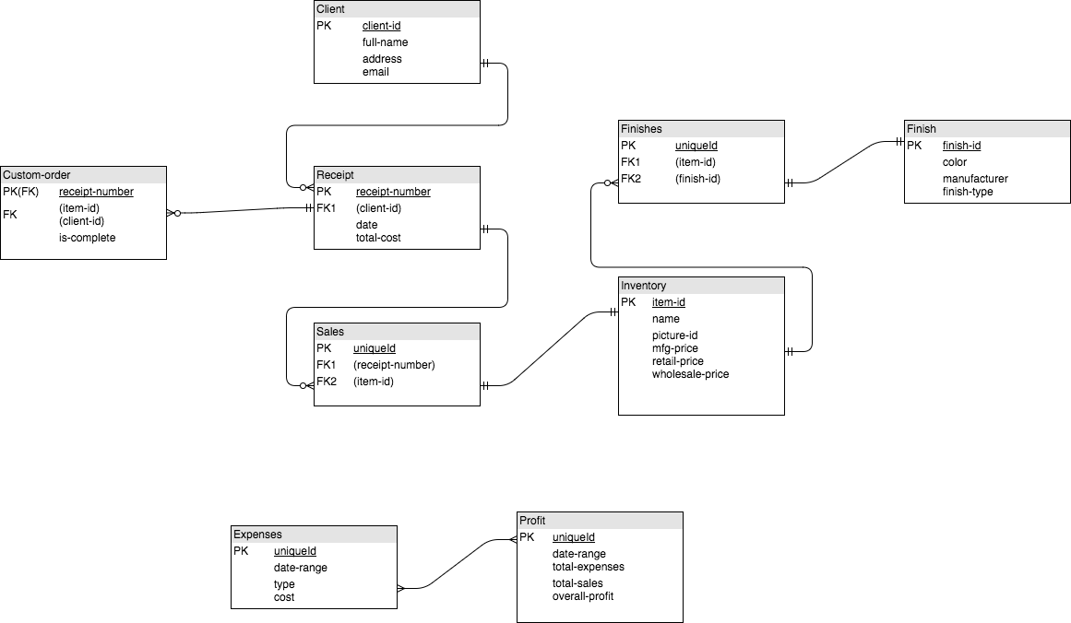 This schema satisfies all of the client’s needs. They are able to reference items purchased by specific customers and identify finishes applied to each item as well as being able to track all expenses, receipts and profits. Once created in mySQL workbench, we had this schema:

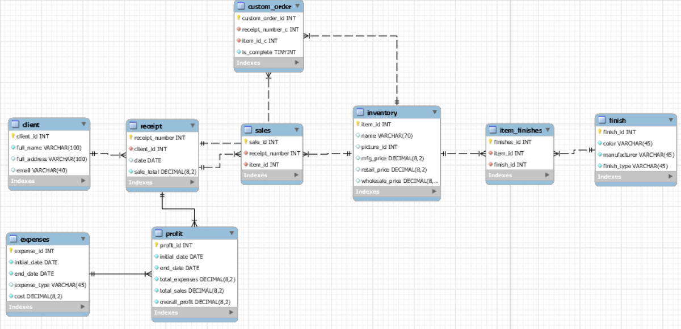

The GUI is user-friendly and easy to use. The following images show the main display of the GUI: 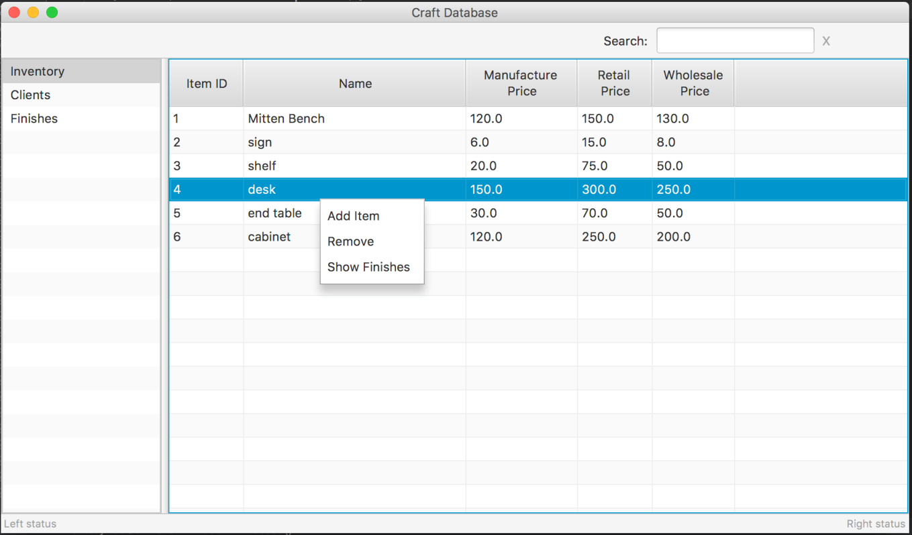

By right-clicking on a data entry, the user is given options of what to do with the entry. The following image shows the “Add item” selection:

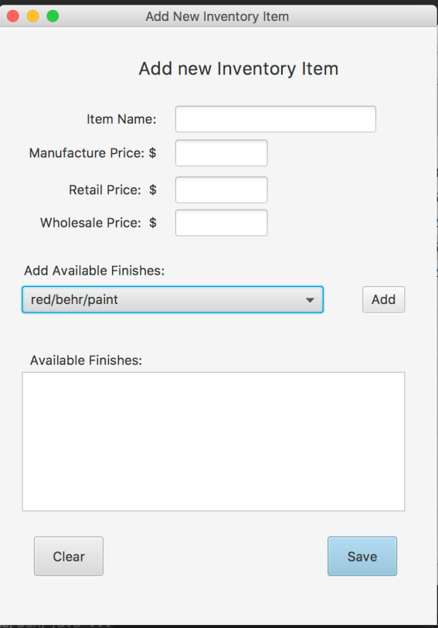

The user is able to easily fill out the form to insert the appropriate information into the table. They are also provided a drop-down menu for selecting the finishes that are on the item.

Overall, we are both quite happy with the outcome. We showed the database to the clients and there are very minor changes to aid in ease of use that we will do to it before we hand it over to them for use. For example, the initial_date and end_date attributes in the expenses table will be combined to just one attribute for the month itself. We also had the idea to load the database onto a Raspberry Pi so the database is a separate entity from other devices in the stakeholder’s home and set it up so they can access it from any computer. This is outside the scope of this project itself and will be investigated beyond the semester to see how plausible it would be.